GUIDANCE FOR FIRST AIDERS SAFE PRACTICE PPE USE:
CORONAVIRUS (COVID-19)

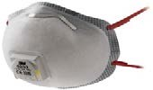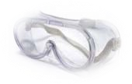 | 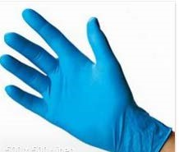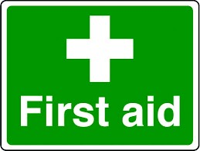
Key Interventions  If, as a First Aid Responder, you can avoid close contact with a player/visitor who may require some level of first aid, do so. This, of course, will not be possible in the event of having to provide emergency lifesaving measures such as an incident of cardiac arrest, heart attack, choking, stroke.  Hand Hygiene  Covid-19 infects through contact with the mucous membranes. First Aid Responders must think of these as the mouth, nose and eyes. It does not infect through the skin. The greatest element of risk is the transfer of the virus via contaminated hands. The key intervention is to minimise hand contamination, avoid touching your face, and clean hands frequently with soap and water or alcohol based hand gel.  PPE Requirements  Firstly clean hands thoroughly with warm water and soap /alcohol based hand gel before putting on / after taking off PPE  The following PPE must be available for responding to first aid incidents.  - Disposable Nitrile Gloves  - Enclosed Eye Protection (i.e. safety goggles)  - Face Mask (FFP2 or appropriate rated) | Disposing of PPE after treatment  - Disposable PPE and any waste should be disposed of after signal use.  - Reusable PPE cleaned/disinfected thoroughly.  - Replenish PPE stock as appropriate.  Minor Injuries  Where practical, the First Aid Responder should avoid close contact and direct the individual through the steps of treating their own injury.  Serious Injuries  Call 999 immediately and request an ambulance  CPR  - It is recommended NOT to perform rescue breaths or mouth-to-mouth ventilation.  - Perform chest compressions only. Should you have given mouth-to-mouth ventilation, there are no additional actions to be taken other than to monitor for symptoms of possible COVID-19 over the following 14 days. Should you develop such symptoms you should follow HSE Guidance.
